**Curves in $R^{3}$**

**1. Regular parameterised Curves**

**Definition 1.1.1.** Let $I⊆R$ be an interval. A parametrised curve in $R^{3}$ is a differentiable function $α:I→R^{3}$. We say it is regular if $α^{'}\left(t\right)≠0$ for all $t∈I$.

*Remark.* Some things to note:

1. Differentiable will mean “of class $C^{∞}$” (usually call smooth) is this course.
2. The image $α\left(I\right)$ of a curve is called the trace of $α$. If the entire trace of $α$ is continued in a single plane, we call $α$ a plane curve.
3. $α^{'}\left(t\right)=\left(x^{'}\left(t\right),y^{'}\left(t\right),z^{'}\left(t\right)\right)$ is called the velocity at time $t$, and $α^{''}\left(t\right)$ the acceleration. Thus, for any given $t∈I$, $α\left(t\right)$ is a point in $R^{3}$ while $α^{'}\left(t\right)$ is a vector, which we “think of as starting at $α\left(t\right)$”.
4. $α$ need not be injective.

**Example 1.1.2.** Some examples of parameterised curves:

1. $α\left(t\right)=\left(\sin{t},\sin{2t},0\right)$ is a regular curve
2. *Circle and helix*. $α\left(t\right)=\left(a\cos{t},a\sin{t},bt\right),a,b,t∈R,a^{2}+b^{2}≠0$.

When $b=0$, $α\left(t\right)$ is a plane circle of radius $a$. When $a=0, α\left(t\right)$ s a straight line.

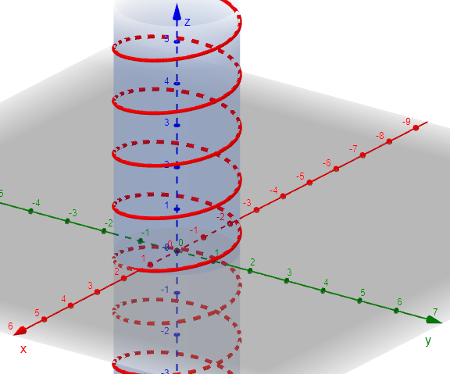In general, $α\left(t\right)$ is a helix. In all cases, $α\left(t\right)$ is a regular curve.

Helix

**Cusp**

1. *Cusp*. A cusp, $α\left(t\right)=\left(t^{2},t^{3}\right),t∈R$. Note that $α$ is not a regular curve since .

1. is not regular since it is not differentiable when $t=0$.

**Definition 1.1.3 (Lecture note).** Let $α:I→R^{3}$ be a parameterised curve. A change of parameters for $α$ is a differentiable bijection $ϕ:\tilde{I}→I$ such that $\tilde{α}=α∘ϕ$ with $ϕ^{'}\left(u\right)≠0$ for all $u∈\tilde{I}$ ( $\tilde{I}∈R$ is an interval). Then $\tilde{α}\left(u\right)≔α\left(ϕ\left(u\right)\right)$ is a parametrised curve with the same trace as $α$; we call it a re-parametrisation. We say $ϕ$ is orientation-preserving if $ϕ^{'}\left(u\right)>0$ for all $u∈\tilde{I}$; otherwise, $ϕ$ is orientation-reversing.

**Definition 1.1.3 (Textbook).** Let $α:I→R^{3},\tilde{α}:\tilde{I}→R^{3}$ be two curves. A differentiable $ϕ:\tilde{I}→I$ such that $\tilde{α}=α∘ϕ$ is called a change of parameters relating to $α$ to $\tilde{α}$. The map $ϕ$ s called orientation preserving if $ϕ^{'}>0.$

*Remark. $α$* is regular if and only if $\tilde{α}$ is regular.

**Definition 1.1.4.** Let $α:I→R^{3}$ be a parametrised curve. The length of $α$ between $a$ and $b$, $a,b∈I$ with $a<b$, is

$$L\left(α{\left.​\right|}_{\left[a,b\right]}\right)≔\int_{a}^{b}{\left\|α^{'}\left(t\right)\right\| dt}$$

We say $α$ is parametrised by arc-length (or “unit-speed”) if $\left\|α^{'}\left(t\right)\right\|=1$.

**Theorem 1.1.5.** Any regular curves $α:I→R^{3}$ can be re-parametrised by arc-length.

*Proof.*

We seek $ϕ:\tilde{I}→I$ such that

$$\left\|\frac{d}{ds}\left(α\left(ϕ\left(s\right)\right)\right)\right\|=1, ∀s$$

Let $I=\left(a,b\right)$ and set $S:I→R$ defined by

$$s\left(t\right)≔\int_{a}^{t}{\left\|α^{'}\left(u\right)\right\|} du$$

By the Fundamental Theorem of Calculus, $s$ is differentiable with

$$\begin{aligned}\frac{d}{dt}s\left(t\right)=\left\|α^{'}\left(t\right)\right\|>0, ∀t∈I\#\left(1.1.5\right)\end{aligned}$$

(greater than 0 since $α$ is regular). Set $\tilde{I}≔s\left(I\right)$. Then $s:I→\tilde{I}$ is an increasing, surjective function. Then since increasing implies injective, so $s$ is bijective, so there exists an inverse $ϕ:\tilde{I}→I$. By the inverse function theorem, $ϕ$ is differentiable and $ϕ^{'}\left(s\right)={\left(s^{'}\left(ϕ\left(s\right)\right)\right)}^{-1}$. Then $\tilde{α}\left(s\right)≔α\left(ϕ\left(s\right)\right)$ is re-parametrisation, with

⏹

*Remark.* In practice, finding $\tilde{α}$ is difficult.

**Example 1.1.6.** Find an arc-length re-parametrisation of

$$α:\left(0,2π\right)→R^{2}, t↦\left(r\cos{t},r\sin{t}\right), r>0.$$

**Solution.**

$$α^{'}\left(t\right)=\left(-r\sin{t},r\cos{t}\right)⟹\left\|α^{'}\left(t\right)\right\|=r,$$

So

$$s\left(t\right)=\int_{0}^{t}{r dx}=rt⟹t=ϕ\left(s\right)=\frac{s}{r}$$

Therefore,

$$β\left(s\right)=\left(r\cos\left(\frac{s}{r}\right),r\sin\left(\frac{s}{r}\right)\right)$$

is the arc-length re-parametrisation.

**Example Done.**

**1.2 The Frenet Frame**

**Definition 1.2.1.** Let $α:I→R^{3}$ be a regular curve, arc-length parametrised (i.e. $\left\|α^{'}\left(s\right)\right\|=1$ for all $s∈I$). The function $κ:I→R,κ\left(s\right)≔\left\|α^{''}\left(s\right)\right\|$, is called the curvature of $α$.

Idea: $κ\left(s\right)$ measures how fast the curve pulls away from the tangent line at $α\left(s\right)$:

$$1$$

$$κ\left(s\right)$$

$$α\left(s\right)$$

$$α^{'}\left(s\right)$$

$$α^{''}\left(s\right)$$

$$α\left(s\right)$$

$$1$$

$$α^{'}\left(s\right)$$

$$α^{''}\left(s\right)$$

$$κ\left(s\right)$$

Parametrisation of tangent line at $α\left(s\right)=\left(x\left(s\right),y\left(s\right),z\left(s\right)\right)$ as $l\left(u\right)=α\left(s\right)+u⋅α^{'}\left(s\right)$. Then using Taylor expansion and Big-O notation, near $s$ we can write

$$α\left(s+t\right)=α\left(s\right)+t⋅α^{'}\left(s\right)+\frac{t^{2}}{2}⋅α^{''}\left(s\right)+O\left(t^{2}\right), \lim_{t→0}{\frac{O\left(t^{2}\right)}{t^{2}}}=0,$$

where we know that $κ\left(s\right)=\left\|α^{''}\left(s\right)\right\|$.

**Example 1.2.2.** Find the curvature of

$$β\left(s\right)≔\left(r\cos\left(\frac{s}{r}\right),r\sin\left(\frac{s}{r}\right)\right), s∈\left(0,2πr\right].$$

**Solution.**

$$β^{'}\left(s\right)=\left(-\sin\left(\frac{s}{r}\right),\cos\left(\frac{s}{r}\right)\right)⟹\left\|β^{'}\left(s\right)\right\|=\sqrt{\sin^{2}\left(\frac{s}{r}\right)+\cos^{2}\left(\frac{s}{r}\right)}=1$$

So $β$ is indeed parametrised by arc-length. Now

$$β^{''}\left(s\right)=\left(-\frac{1}{r}\cos\left(\frac{s}{r}\right),\frac{1}{r}\sin\left(\frac{s}{r}\right)\right)⟹\left\|β^{''}\left(s\right)\right\|=\sqrt{\frac{1}{r^{2}}\left(\sin^{2}\left(\frac{s}{r}\right)+\cos^{2}\left(\frac{s}{r}\right)\right)}=\frac{1}{r}$$

**Example Done.**

**Definition 1.2.3.** Let $α:I→R^{3}$ be a regular curve parametrised by arc-length and with $κ\left(s\right)≠0$ for all . Then

1. is the tangent vector of at .

3. is the binormal vector of $α$ at $α\left(s\right)$.

The mapping $s↦\left\{t\left(s\right),n\left(s\right),b\left(s\right)\right\}$ is called the Frenet frame of .

**Theorem 1.2.4.** Let $α:I→R^{3}$ be a regular curve parametrised by arc-length and with $κ\left(s\right)≠0$ for all $s∈I$. Then $∀s∈I$, $\left\{t\left(s\right),n\left(s\right),b\left(s\right)\right\}$ is an orthonormal basis of $R^{3}$.

*Proof. $α$* is unit-speed parametrised, so $\left\|t\left(s\right)\right\|=1$ for all $s∈I$. By definition of $κ\left(s\right)$,

$$\left\|n\left(s\right)\right\|=\left\|\frac{α^{''}\left(s\right)}{κ\left(s\right)}\right\|=\frac{1}{\left\|κ\left(s\right)\right\|}⋅\left\|α^{''}\left(s\right)\right\|=1, ∀s∈I$$

We now claim that $t\left(s\right)⊥n\left(s\right)$ for all $s∈I$. Indeed, using that $1={\left\|t\left(s\right)\right\|}^{2}$ for all $s∈I$, we differentiate with respect to $s$:

$$0=\frac{d}{ds}〈t\left(s\right),t\left(s\right)〉=〈t^{'}\left(s\right),t\left(s\right)〉+〈t\left(s\right),t^{'}\left(s\right)〉$$

$$=2〈α^{''}\left(s\right),α^{'}\left(s\right)〉=2κ\left(s\right)〈\frac{α^{''}\left(s\right)}{κ\left(s\right)},α^{'}\left(s\right)〉=2κ\left(s\right)〈n\left(s\right),t\left(s\right)〉$$

Since $κ\left(s\right)≠0$ for all $s∈I$, it follows that $〈n\left(s\right),t\left(s\right)〉=0$ for all $s∈I$.

Finally, $b\left(s\right)=t\left(s\right)×n\left(s\right)$ is orthogonal to both $t\left(s\right)$ and $n\left(s\right)$ by definition. Moreover,

$$\left\|b\left(s\right)\right\|=\left\|t\left(s\right)×n\left(s\right)\right\|=\left\|t\left(s\right)\right\|⋅\left\|n\left(s\right)\right\|⋅\left|\sin\left(\operatorname{ang}\left(t,n\right)\right)\right|=1⋅1⋅\left|\sin\left(±\frac{π}{2}\right)\right|=1,$$

where $ang\left(t,n\right)$ denotes the angle between $t$ and .

⏹

**Definition 1.2.5.** Let $α:I→R^{3}$ be a regular curve parametrised by arc-length with $κ\left(s\right)≠0$ for all . Then

1. The plane span $\left\{t\left(s\right),n\left(s\right)\right\}$ is called the osculating plane of .

2. The plane span $\left\{n\left(s\right),b\left(s\right)\right\}$ is called the normal plane of .

3. The plane span $\left\{t\left(s\right),b\left(s\right)\right\}$ is called the rectifying plane of $α\left(s\right)$.

**Lemma 1.2.6.** Let $α:I→R^{3}$ be a regular, unit-speed curve with $κ\left(s\right)≠0$ for all $s∈I$. Then $b^{'}\left(s\right)$ is a multiple of $n\left(s\right)$.

*Proof.* We need to show that $b^{'}\left(s\right)⊥t\left(s\right)$ and $b^{'}\left(s\right)⊥b\left(s\right)$. Differentiating ${\left\|b\left(s\right)\right\|}^{2}≡1$ yields

$$0=2〈b^{'}\left(s\right),b\left(s\right)〉⟹b^{'}\left(s\right)⊥b\left(s\right)$$

Differentiating $0≡〈b\left(s\right),t\left(s\right)〉$ gives us

$$0=〈b^{'}\left(s\right),t\left(s\right)〉+〈b\left(s\right),t^{'}\left(s\right)〉=〈b^{'}\left(s\right),t\left(s\right)〉+〈b\left(s\right),κ\left(s\right)n\left(s\right)〉=〈b^{'}\left(s\right),t\left(s\right)〉+κ\left(s\right)〈b\left(s\right),n\left(s\right)〉$$

$$⟹〈b^{'}\left(s\right),t\left(s\right)〉=0.$$

Now since $\left\{t\left(s\right),n\left(s\right),b\left(s\right)\right\}$ is an orthonormal basis for $R^{3}$, we can write

$$b^{'}\left(s\right)=x_{1}t\left(s\right)+x_{2}n\left(s\right)+x_{3}b\left(s\right), x_{1},x_{2},x_{3}∈R$$

But from above, $0=〈b^{'}\left(s\right),n\left(s\right)〉=x_{1}$ and $0=〈b^{'}\left(s\right),b\left(s\right)〉=x_{3}$, so .

⏹

**Definition 1.2.7.** Let $α:I→R^{3}$ be a regular, unit-speed curve with $κ\left(s\right)≠0$ for all $s∈I$. For each $s∈I$, we define the torsion of $α$ at $α\left(s\right)$ to be the unique scalar $τ\left(s\right)$ such that

$b^{'}\left(s\right)=τ\left(s\right)n\left(s\right)$. In other words, $τ\left(s\right)=〈b^{'}\left(s\right),n\left(s\right)〉$.

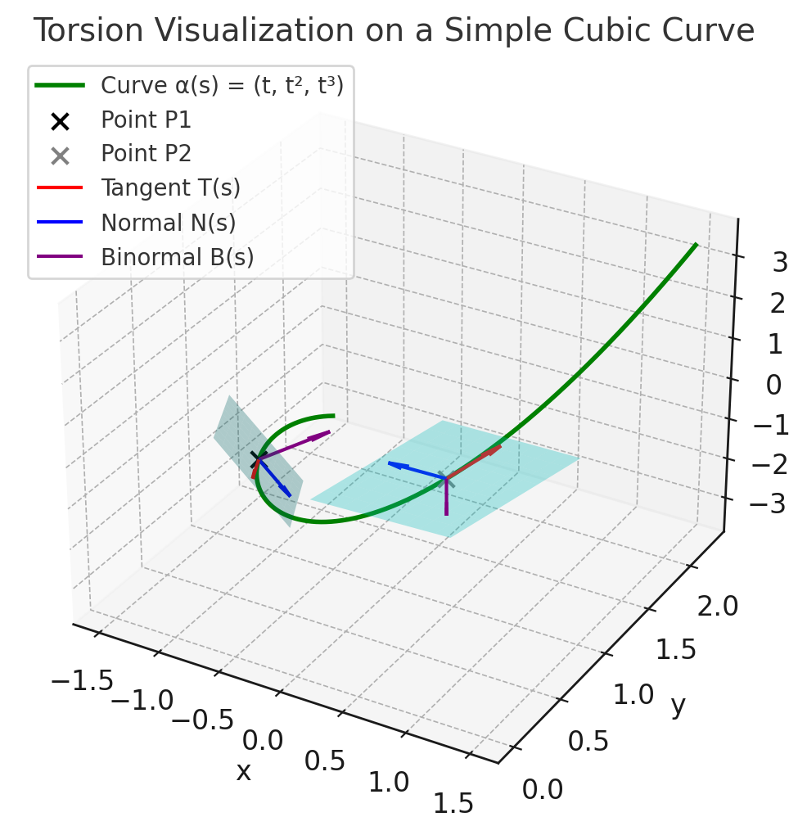*Remark.* Observe that $b\left(s\right)$ determines the osculating plane. Thus, the torsion measures how much the curve deviated itself from its osculating plane.